training 1 epoch...

84.79397392272949 seconds used......

1 training finished! average train loss: 0.6127760459325815

total clf loss: 143.43559315800667 total adv loss: 74.45309493690729

evaluating...

Confusion matrix, without normalization

[[ 225 52 17]

[ 687 3040 94]

[ 69 15 758]]

Normalized confusion matrix

[[0.76530612 0.17687075 0.05782313]

[0.17979586 0.79560325 0.02460089]

[0.08194774 0.01781473 0.90023753]]

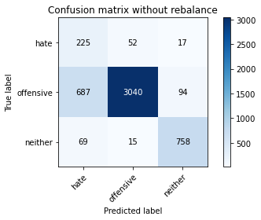

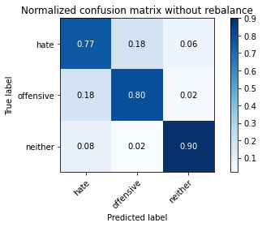

precision recall f1-score support

hate 0.23 0.77 0.35 294

offensive 0.98 0.80 0.88 3821

neither 0.87 0.90 0.89 842

accuracy 0.81 4957

macro avg 0.69 0.82 0.71 4957

weighted avg 0.92 0.81 0.85 4957

average eval_loss: 0.4761050983227992, accuracy: 0.8115795844260641

training 2 epoch...

84.08608317375183 seconds used......

2 training finished! average train loss: 0.37695299108561714

total clf loss: 88.25413013249636 total adv loss: 46.176968993619084

evaluating...

Confusion matrix, without normalization

[[ 207 70 17]

[ 451 3273 97]

[ 58 11 773]]

Normalized confusion matrix

[[0.70408163 0.23809524 0.05782313]

[0.11803193 0.85658205 0.02538602]

[0.06888361 0.01306413 0.91805226]]

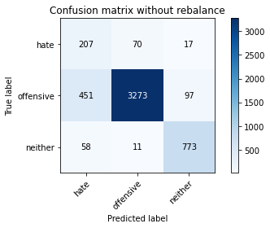

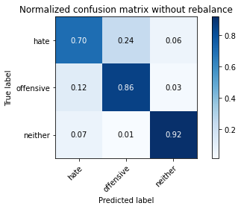

precision recall f1-score support

hate 0.29 0.70 0.41 294

offensive 0.98 0.86 0.91 3821

neither 0.87 0.92 0.89 842

accuracy 0.86 4957

macro avg 0.71 0.83 0.74 4957

weighted avg 0.92 0.86 0.88 4957

average eval_loss: 0.41367580037102597, accuracy: 0.8579786160984466

training 3 epoch...

84.35272216796875 seconds used......

3 training finished! average train loss: 0.25474397179654296

total clf loss: 59.944366509094834 total adv loss: 37.25481841061264

evaluating...

Confusion matrix, without normalization

[[ 235 43 16]

[ 805 2925 91]

[ 61 20 761]]

Normalized confusion matrix

[[0.79931973 0.1462585 0.05442177]

[0.21067783 0.76550641 0.02381576]

[0.07244656 0.02375297 0.90380048]]

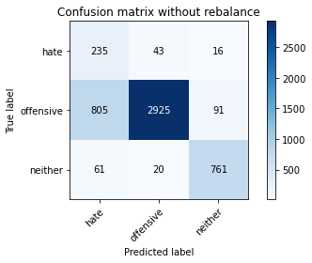

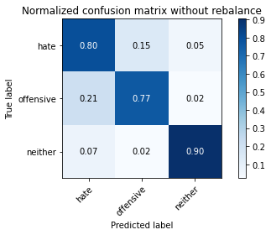

precision recall f1-score support

hate 0.21 0.80 0.34 294

offensive 0.98 0.77 0.86 3821

neither 0.88 0.90 0.89 842

accuracy 0.79 4957

macro avg 0.69 0.82 0.70 4957

weighted avg 0.92 0.79 0.83 4957

average eval_loss: 0.5283725833424628, accuracy: 0.7910026225539641

training 4 epoch...

84.07985877990723 seconds used......

4 training finished! average train loss: 0.16364751670411543

total clf loss: 38.55837896745652 total adv loss: 24.934903268702328

evaluating...

Confusion matrix, without normalization

[[ 212 65 17]

[ 632 3094 95]

[ 45 25 772]]

Normalized confusion matrix

[[0.72108844 0.22108844 0.05782313]

[0.16540173 0.80973567 0.0248626 ]

[0.05344418 0.02969121 0.91686461]]

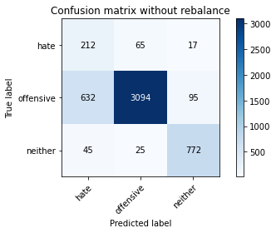

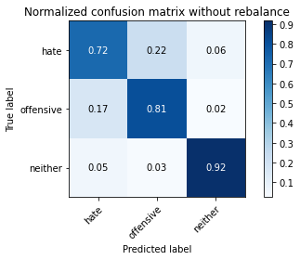

precision recall f1-score support

hate 0.24 0.72 0.36 294

offensive 0.97 0.81 0.88 3821

neither 0.87 0.92 0.89 842

accuracy 0.82 4957

macro avg 0.69 0.82 0.71 4957

weighted avg 0.91 0.82 0.85 4957

average eval_loss: 0.466074170148017, accuracy: 0.822675005043373

training 5 epoch...

83.96275734901428 seconds used......

5 training finished! average train loss: 0.08820797079406156

total clf loss: 20.939589654561132 total adv loss: 16.563445804349612

evaluating...

Confusion matrix, without normalization

[[ 217 57 20]

[ 666 3061 94]

[ 40 37 765]]

Normalized confusion matrix

[[0.73809524 0.19387755 0.06802721]

[0.17429992 0.80109919 0.02460089]

[0.04750594 0.04394299 0.90855107]]

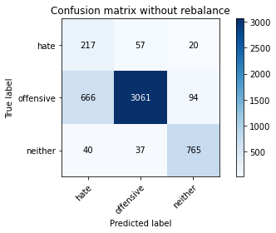

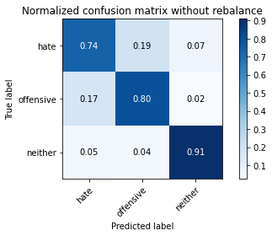

precision recall f1-score support

hate 0.24 0.74 0.36 294

offensive 0.97 0.80 0.88 3821

neither 0.87 0.91 0.89 842

accuracy 0.82 4957

macro avg 0.69 0.82 0.71 4957

weighted avg 0.91 0.82 0.85 4957

average eval_loss: 0.6121167349291464, accuracy: 0.8156142828323583

training 6 epoch...

84.04390716552734 seconds used......

6 training finished! average train loss: 0.0658074380358142

total clf loss: 15.692578696878627 total adv loss: 13.769655014417367

evaluating...

Confusion matrix, without normalization

[[ 230 50 14]

[ 774 2921 126]

[ 55 23 764]]

Normalized confusion matrix

[[0.78231293 0.17006803 0.04761905]

[0.20256477 0.76445957 0.03297566]

[0.06532067 0.02731591 0.90736342]]

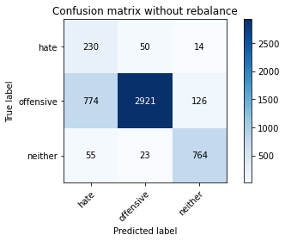

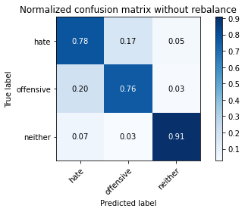

precision recall f1-score support

hate 0.22 0.78 0.34 294

offensive 0.98 0.76 0.86 3821

neither 0.85 0.91 0.88 842

accuracy 0.79 4957

macro avg 0.68 0.82 0.69 4957

weighted avg 0.91 0.79 0.83 4957

average eval_loss: 0.8033419488479026, accuracy: 0.7897922130320758

training 7 epoch...

84.04690027236938 seconds used......

7 training finished! average train loss: 0.05334199442356629

total clf loss: 12.750297856982797 total adv loss: 11.76646340303705

evaluating...

Confusion matrix, without normalization

[[ 203 66 25]

[ 543 3096 182]

[ 26 16 800]]

Normalized confusion matrix

[[0.69047619 0.2244898 0.08503401]

[0.1421094 0.81025909 0.04763151]

[0.03087886 0.01900238 0.95011876]]

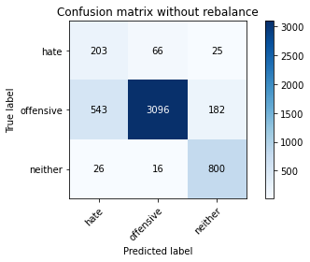

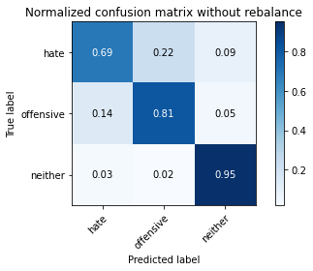

precision recall f1-score support

hate 0.26 0.69 0.38 294

offensive 0.97 0.81 0.88 3821

neither 0.79 0.95 0.87 842

accuracy 0.83 4957

macro avg 0.68 0.82 0.71 4957

weighted avg 0.90 0.83 0.85 4957

average eval_loss: 0.7782742908545222, accuracy: 0.8269114383699818

training 8 epoch...

84.21024060249329 seconds used......

8 training finished! average train loss: 0.04505293106500942

total clf loss: 10.84338612051215 total adv loss: 11.42635635939223

evaluating...

Confusion matrix, without normalization

[[ 222 54 18]

[ 714 3016 91]

[ 38 46 758]]

Normalized confusion matrix

[[0.75510204 0.18367347 0.06122449]

[0.18686208 0.78932217 0.02381576]

[0.04513064 0.05463183 0.90023753]]

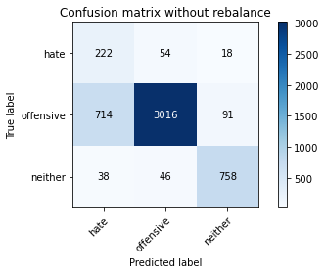

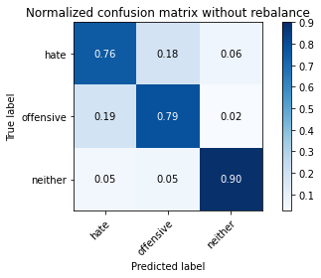

precision recall f1-score support

hate 0.23 0.76 0.35 294

offensive 0.97 0.79 0.87 3821

neither 0.87 0.90 0.89 842

accuracy 0.81 4957

macro avg 0.69 0.81 0.70 4957

weighted avg 0.91 0.81 0.84 4957

average eval_loss: 0.8564268329301764, accuracy: 0.8061327415775671

training 9 epoch...

83.88181591033936 seconds used......

9 training finished! average train loss: 0.02828059061006602

total clf loss: 7.021897474245634 total adv loss: 11.478456879700389

evaluating...

Confusion matrix, without normalization

[[ 227 49 18]

[ 840 2893 88]

[ 56 36 750]]

Normalized confusion matrix

[[0.77210884 0.16666667 0.06122449]

[0.21983774 0.75713164 0.02303062]

[0.06650831 0.04275534 0.89073634]]

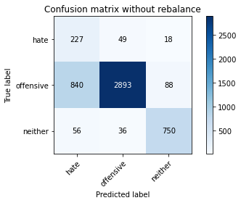

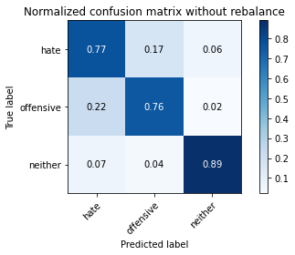

precision recall f1-score support

hate 0.20 0.77 0.32 294

offensive 0.97 0.76 0.85 3821

neither 0.88 0.89 0.88 842

accuracy 0.78 4957

macro avg 0.68 0.81 0.68 4957

weighted avg 0.91 0.78 0.83 4957

average eval_loss: 0.9988770033957386, accuracy: 0.7807141416179141

training 10 epoch...

84.01139187812805 seconds used......

10 training finished! average train loss: 0.023569497568052867

total clf loss: 6.142459403141402 total adv loss: 15.372278636677947

evaluating...

Confusion matrix, without normalization

[[ 234 42 18]

[ 849 2871 101]

[ 42 24 776]]

Normalized confusion matrix

[[0.79591837 0.14285714 0.06122449]

[0.22219314 0.75137399 0.02643287]

[0.04988124 0.02850356 0.9216152 ]]

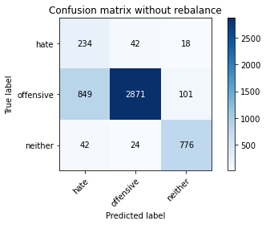

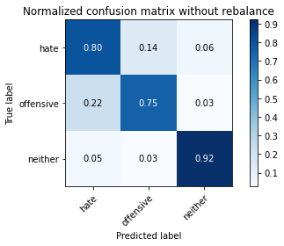

precision recall f1-score support

hate 0.21 0.80 0.33 294

offensive 0.98 0.75 0.85 3821

neither 0.87 0.92 0.89 842

accuracy 0.78 4957

macro avg 0.68 0.82 0.69 4957

weighted avg 0.91 0.78 0.83 4957

average eval_loss: 1.0417425554246413, accuracy: 0.7829332257413758